Nama : Andri Firman Saputra  
NIM : 201011402125  
Kelas : 02TPLP023  
Tugas : Algoritma II – UAS Semester 2

1. Insertion, selection dan bubble sort 4, 2, 5, 1, 8, 7,10, 9, 6 (ascending)

Insertion Sort No. 1

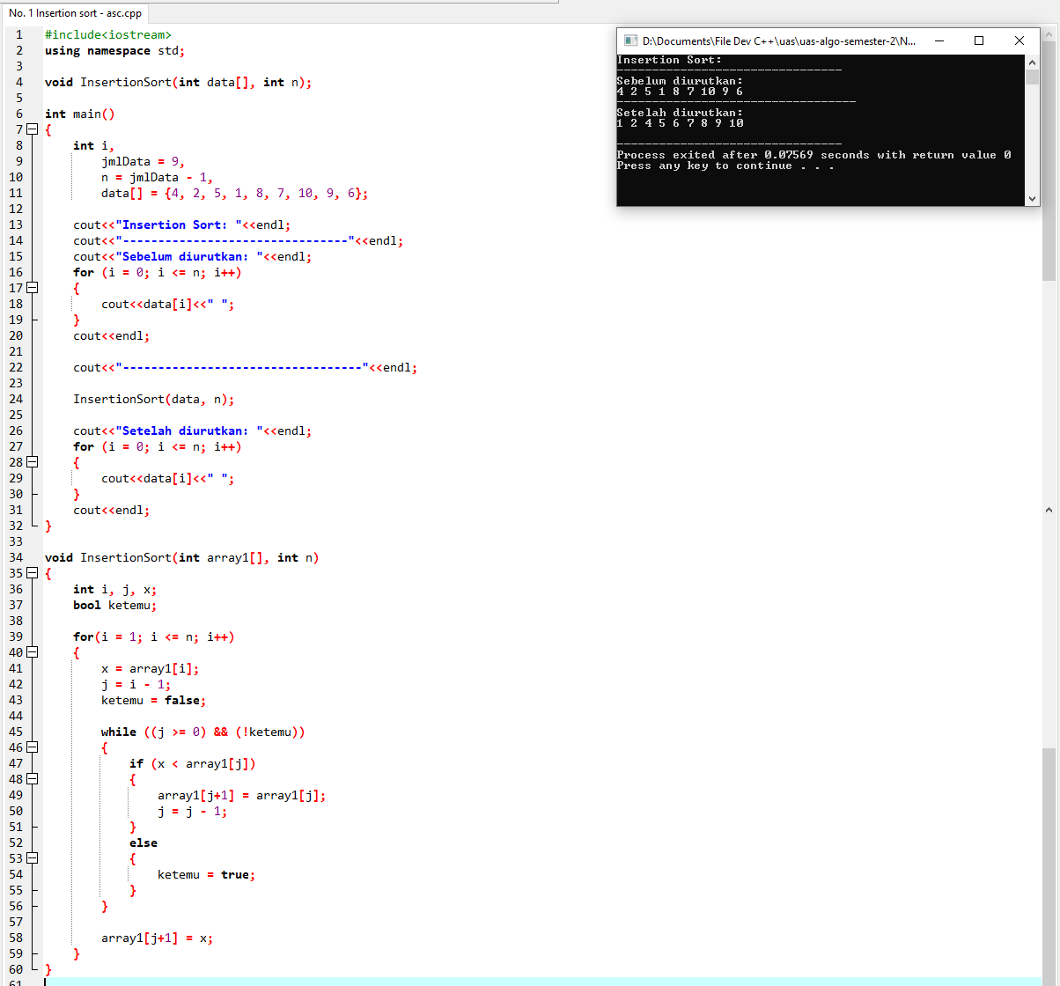

Selection Sort No. 1

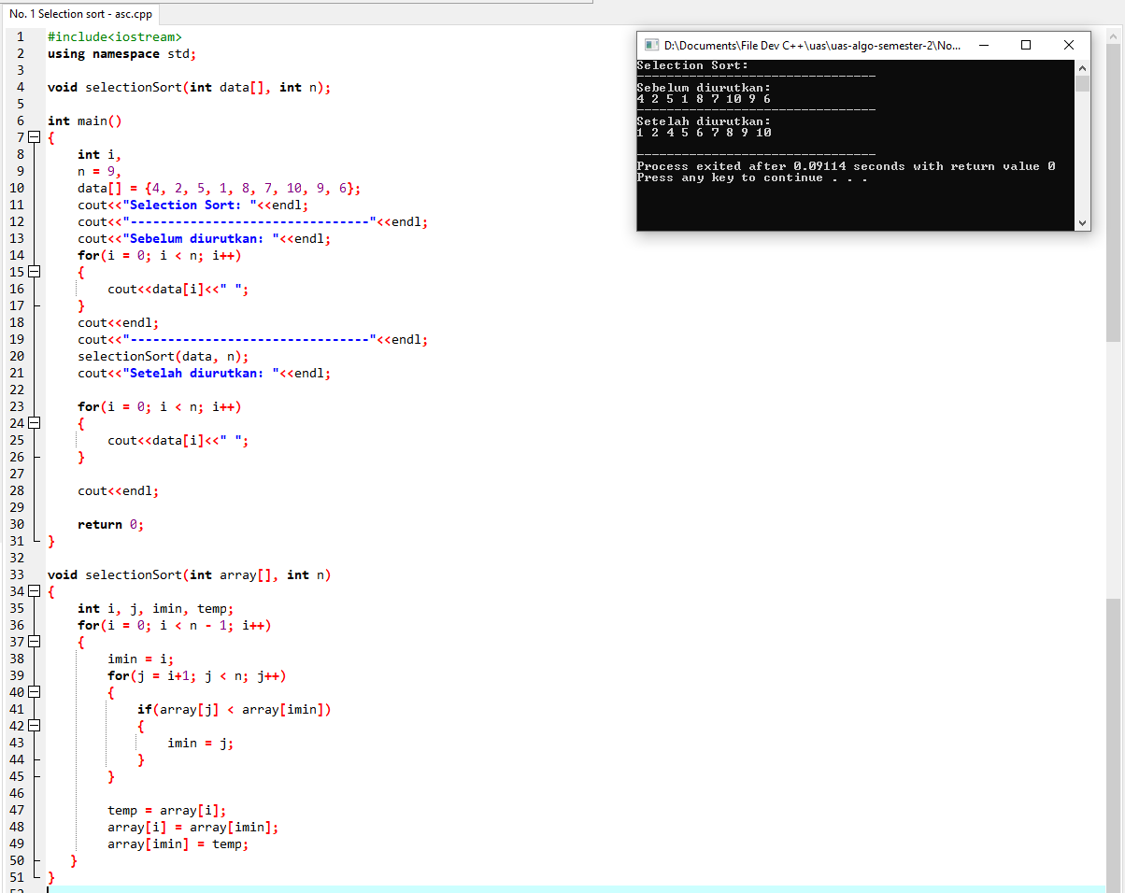

Bubble Sort No. 1

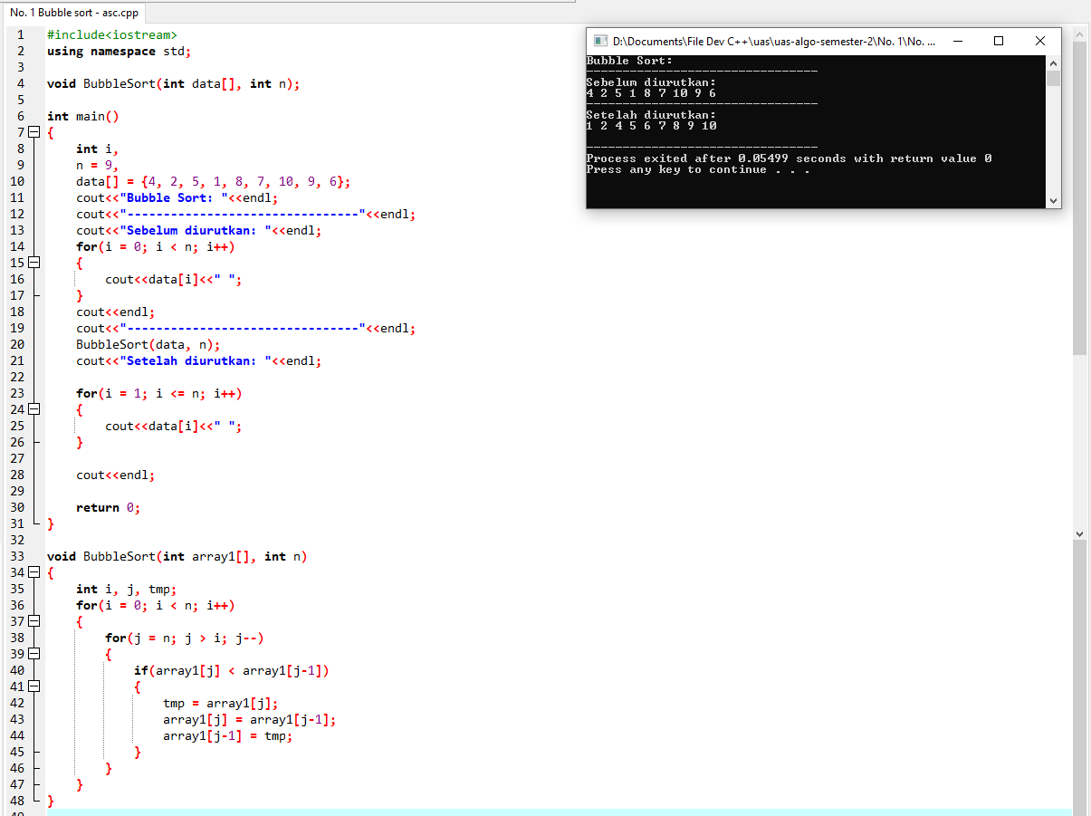

1. Insertion, selection dan bubble sort 1, 10, 3, 8, 5, 6, 7, 4, 9, 2 (descending)

Insertion Sort No. 2

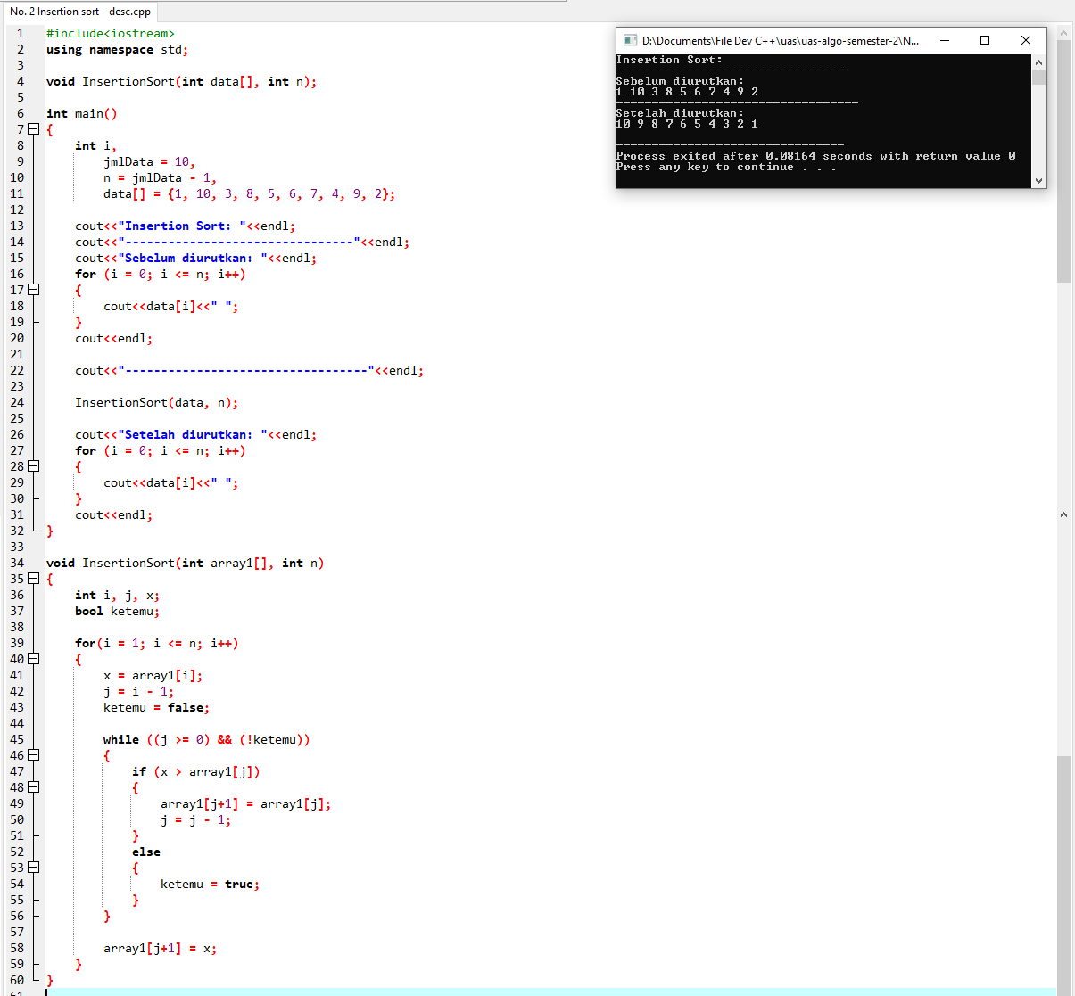

Selection Sort No. 2

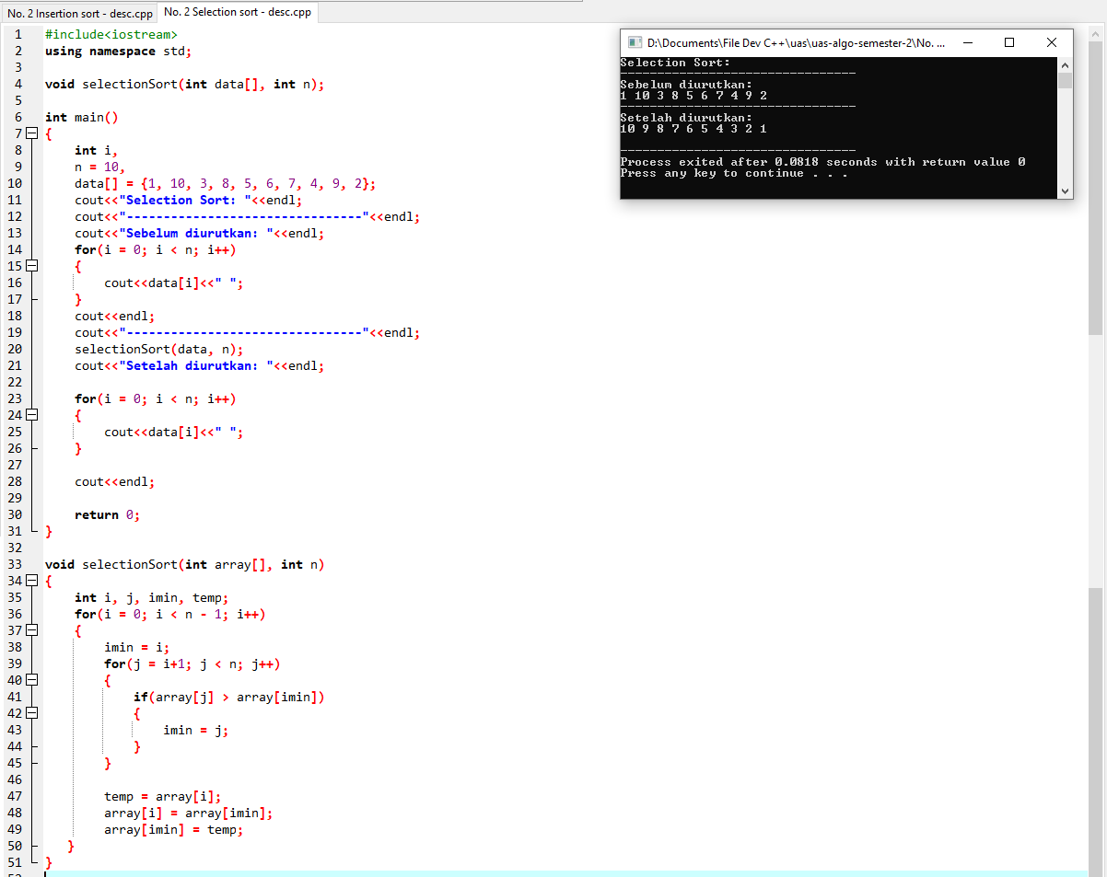

Bubble Sort No. 2

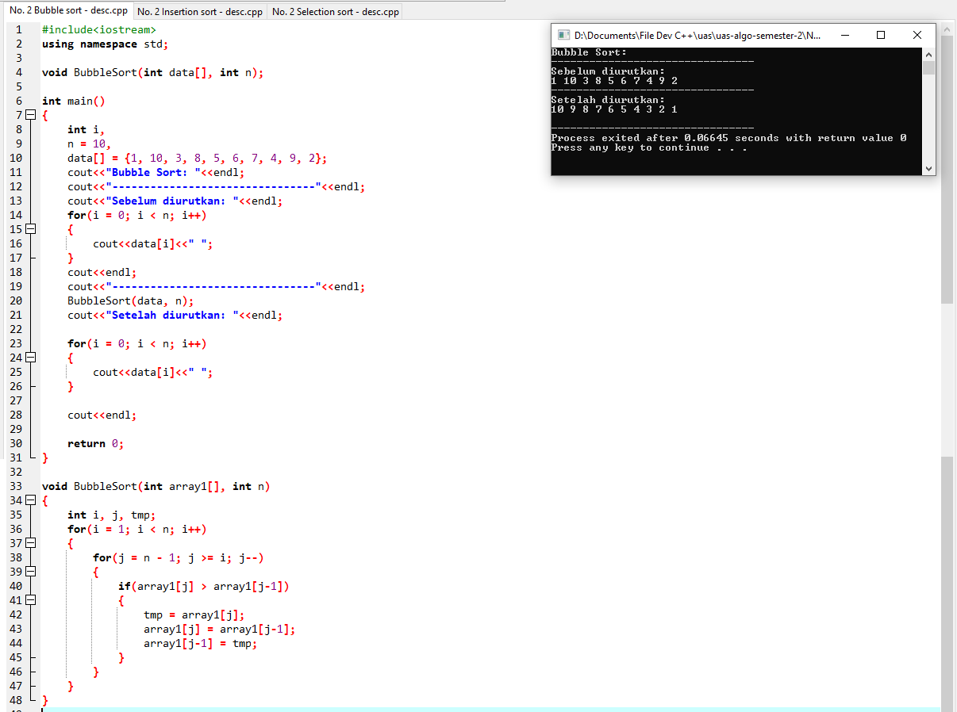

1. Insertion, selection dan bubble sort 5, 34, 32, 25, 75, 42, 22, 2 (ascending)

Insertion Sort No. 3

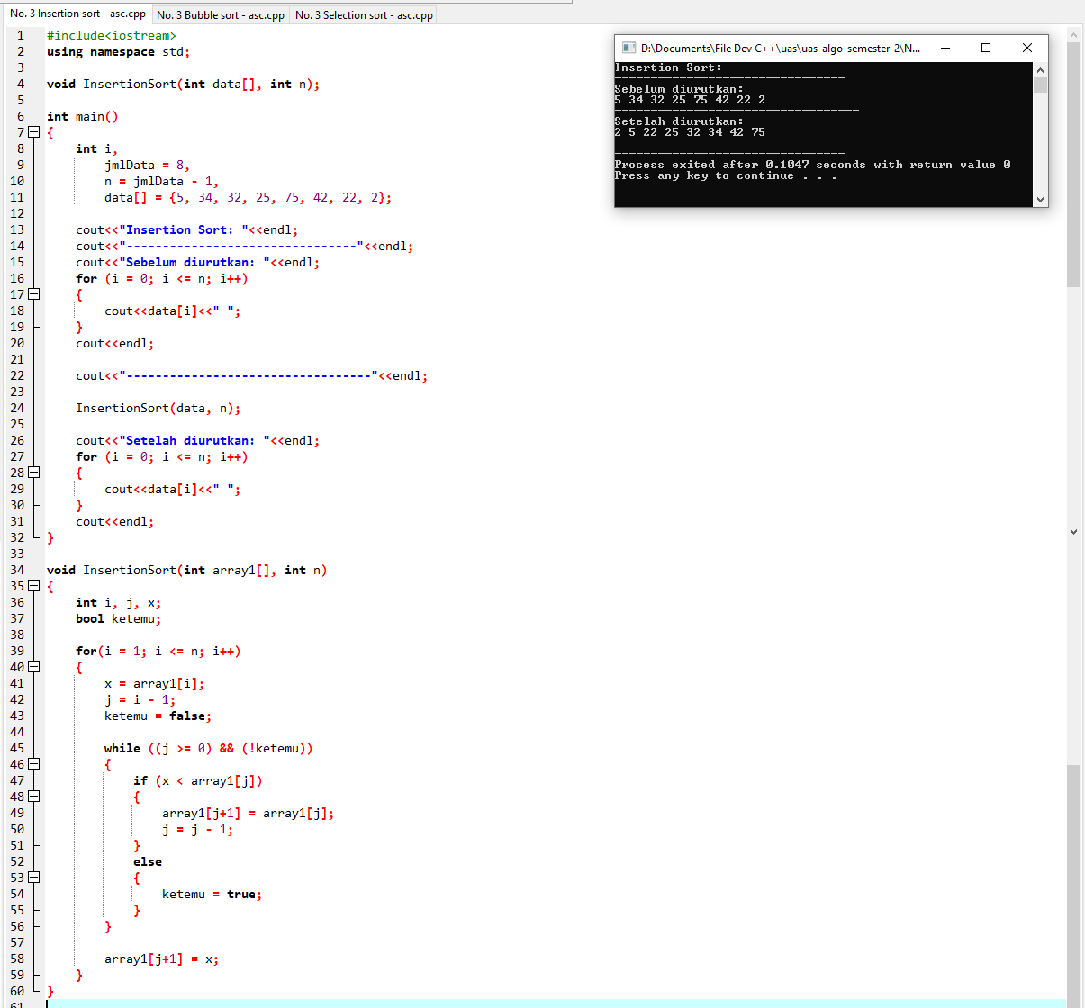

Selection Sort No. 3

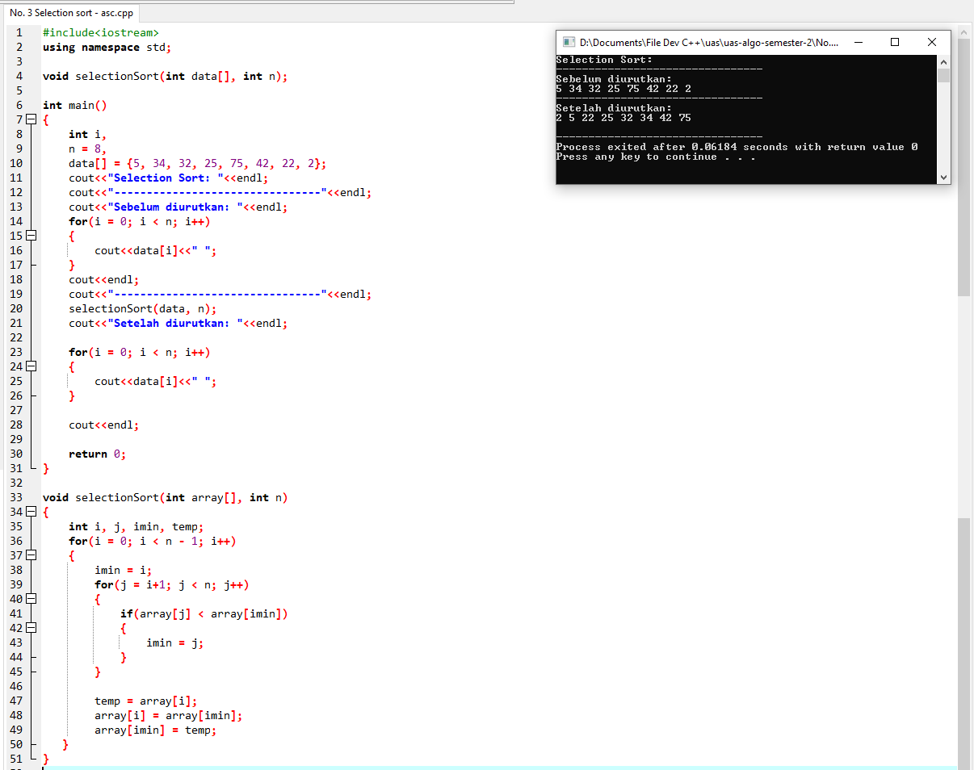

Bubble Sort No. 3

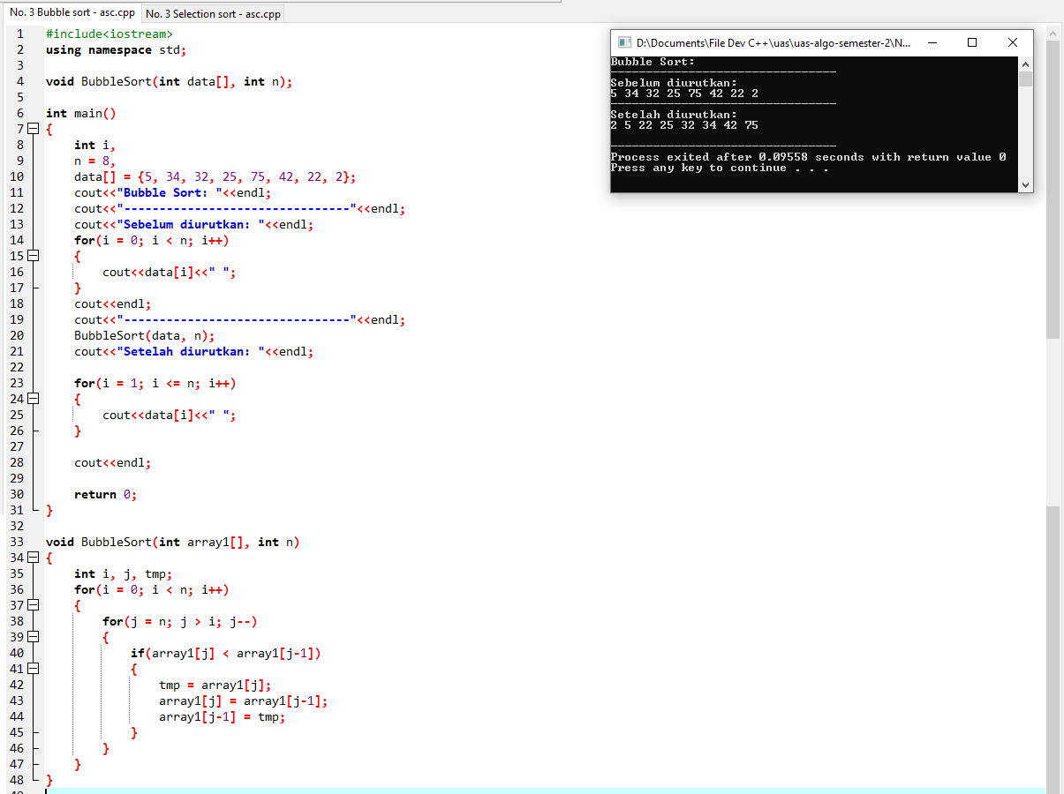

1. Insertion, selection dan bubble sort 21, 83, 42, 11, 10, 9, 3, 20, 102, 27, 15, 92, 2 (descending)

Insertion Sort No. 4

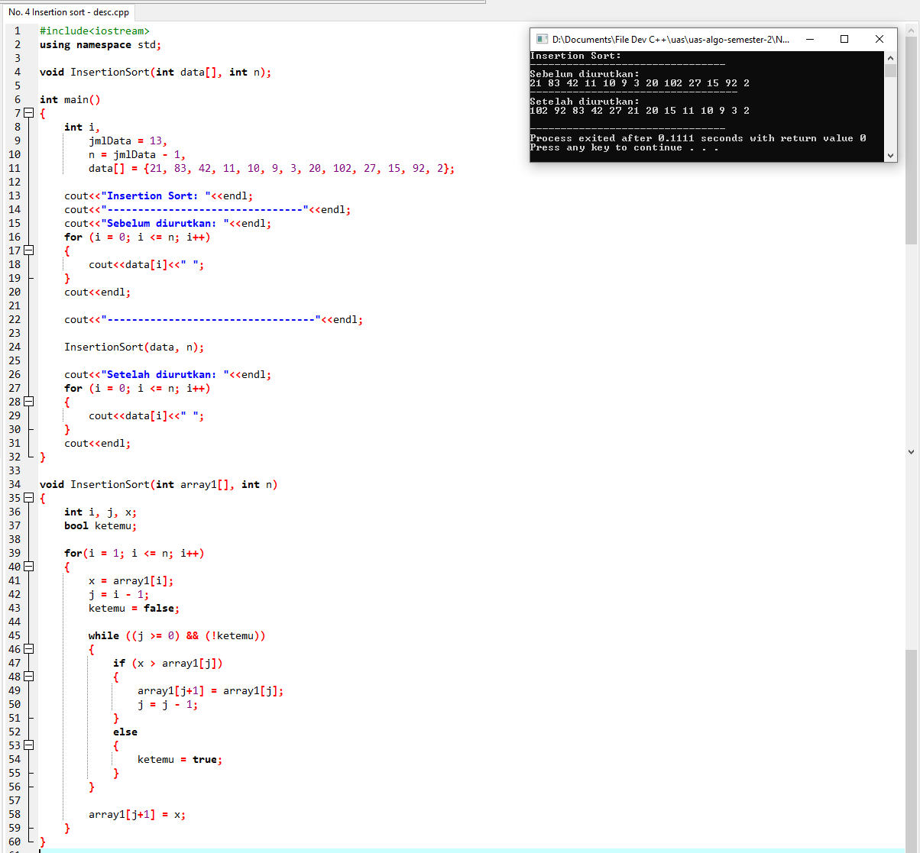

Selection Sort No. 4

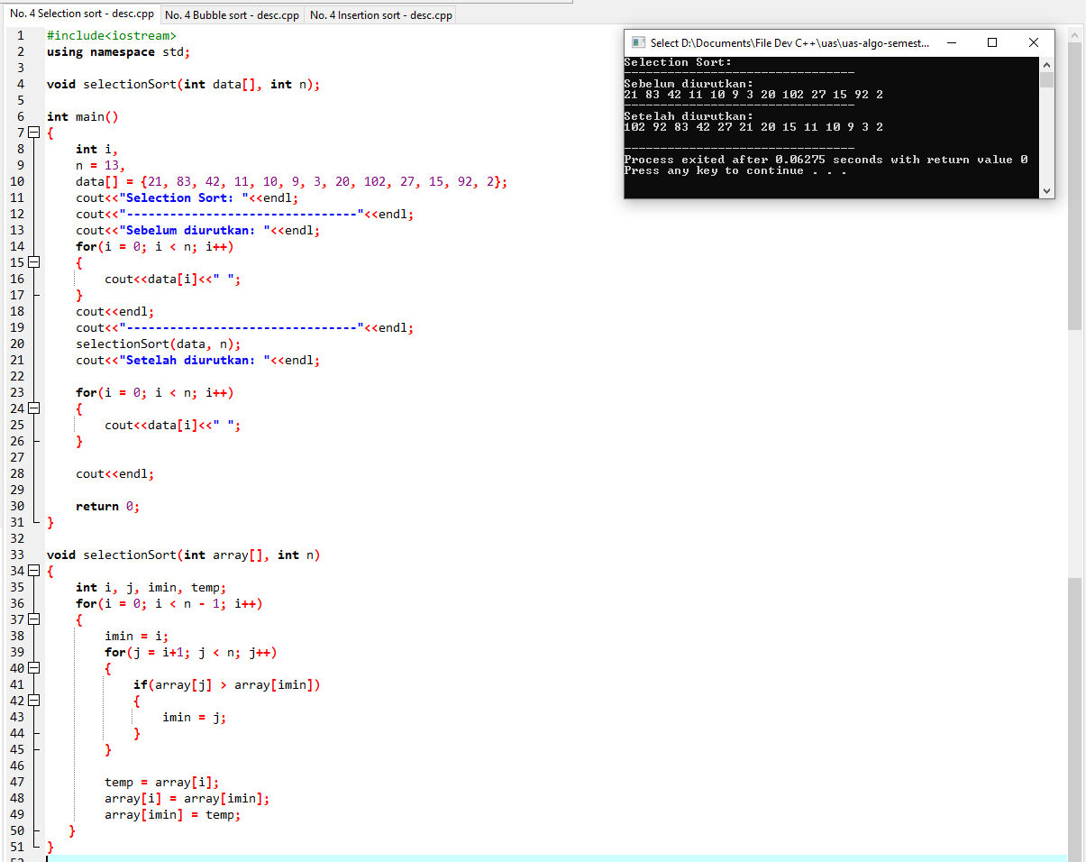

Bubble Sort No. 4

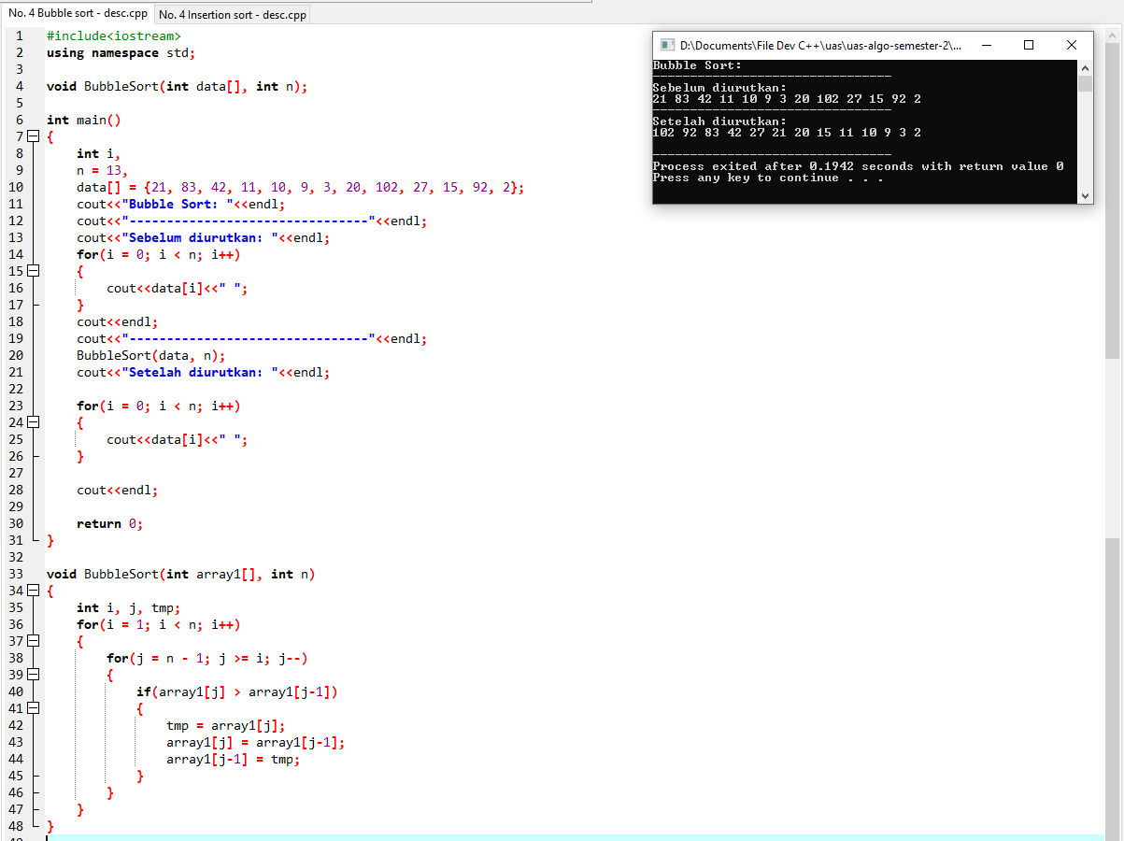

1. Insertion, selection dan bubble sort 102, 92, 83, 42, 27, 21, 20, 15, 11, 10, 9, 3, 2 (ascending)

Insertion Sort No. 5

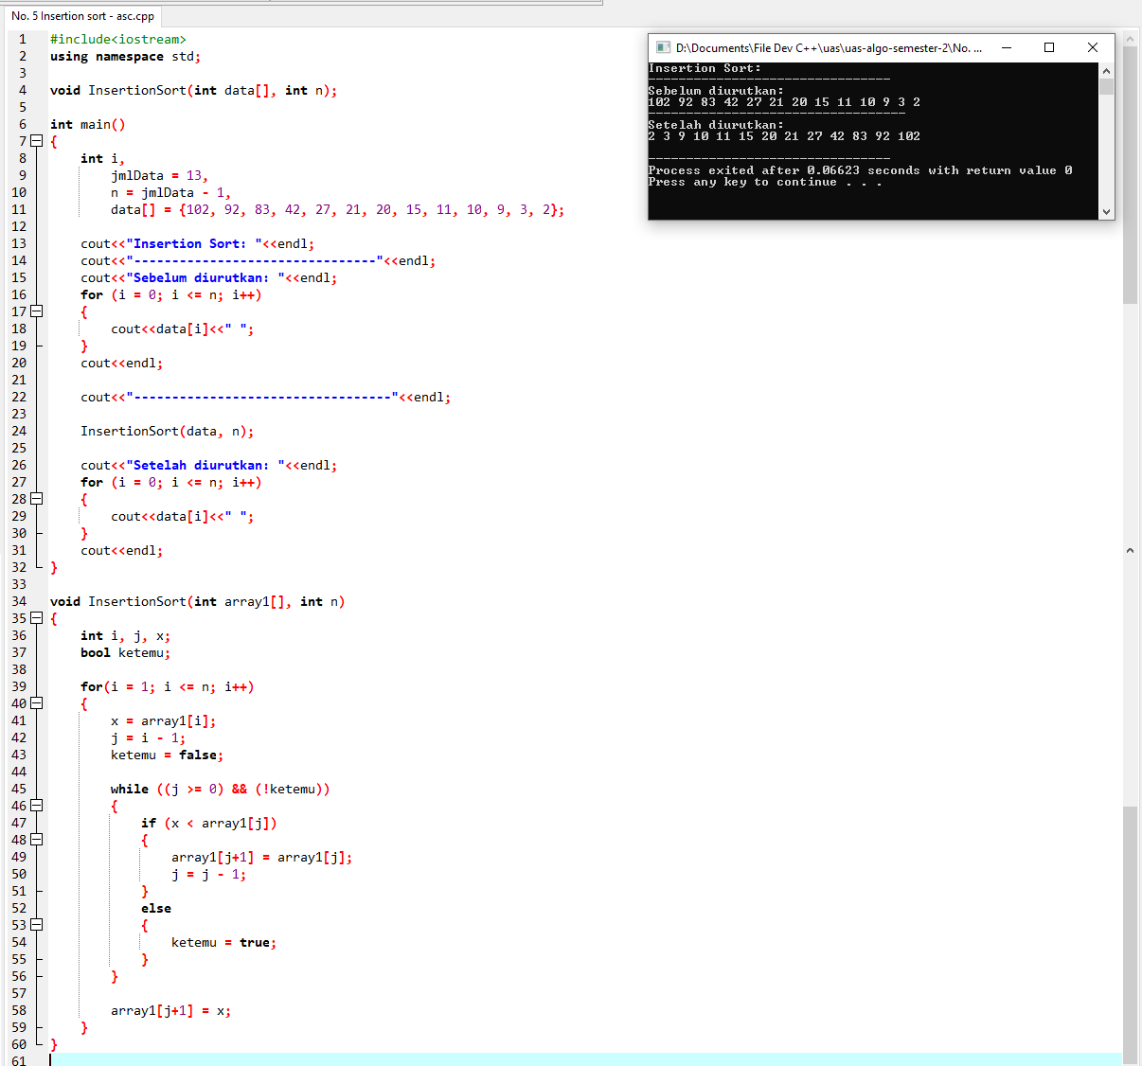

Selection Sort No. 5

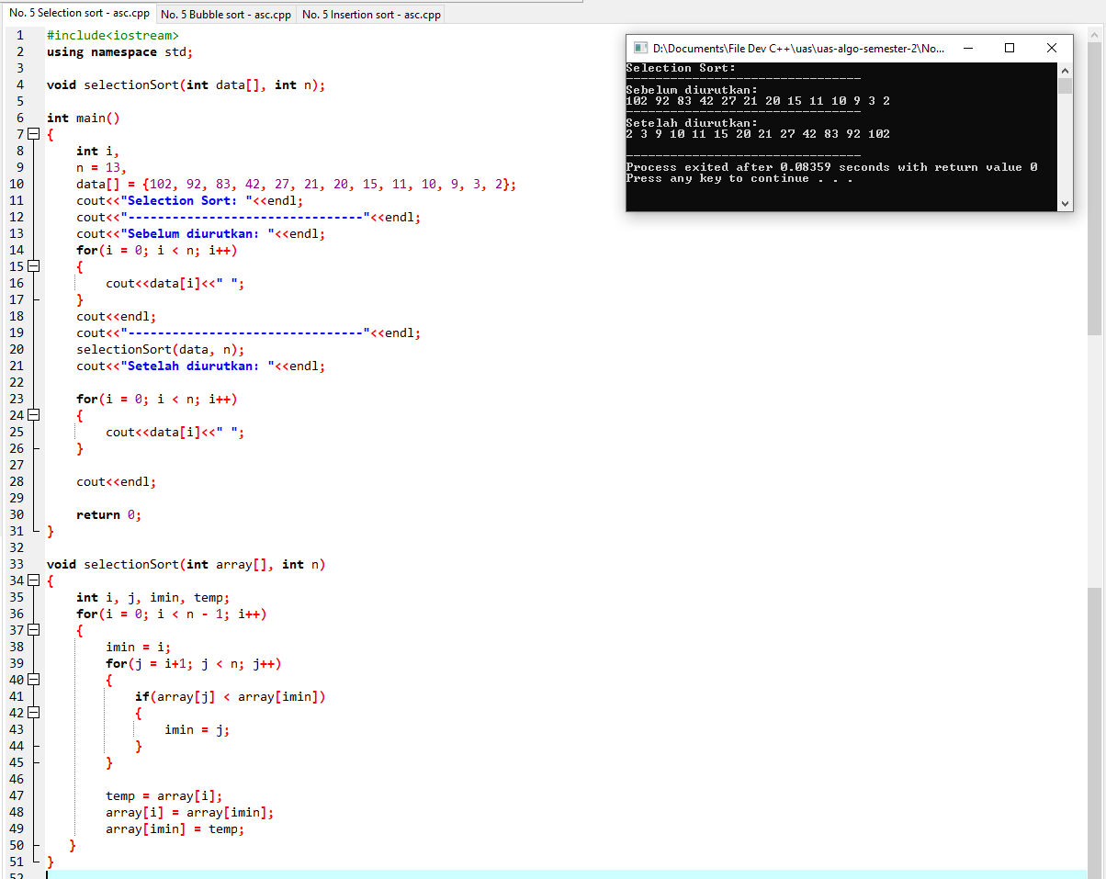

Bubble Sort No. 5

